ASSIGNMENT 2
FINAL LAB TASKS BY OM 2280156
COURSE CC

LAB 9a

Resource Group Created
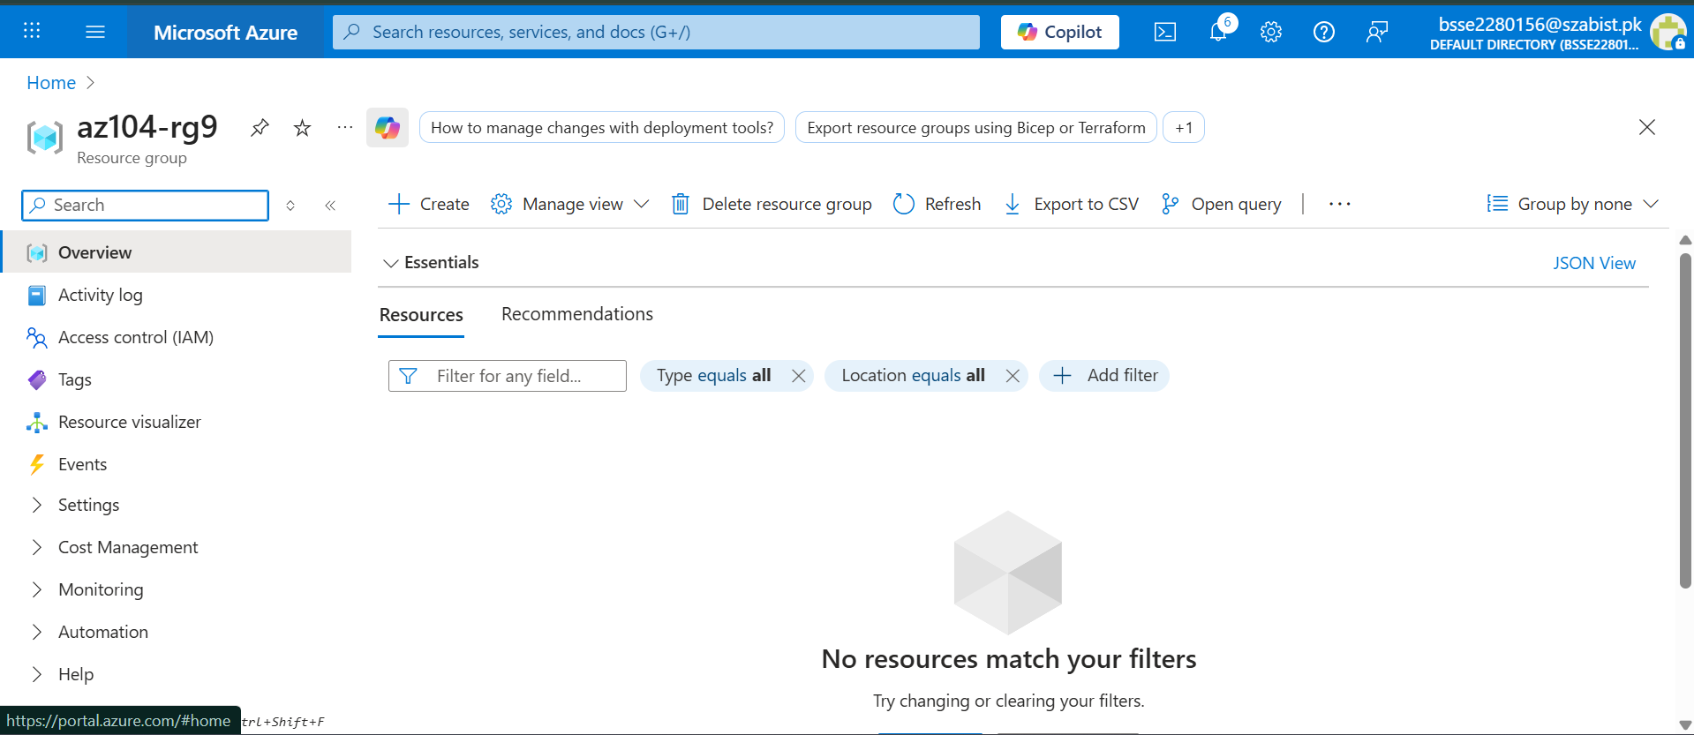

Web App Basics tab (Name + Region visible)
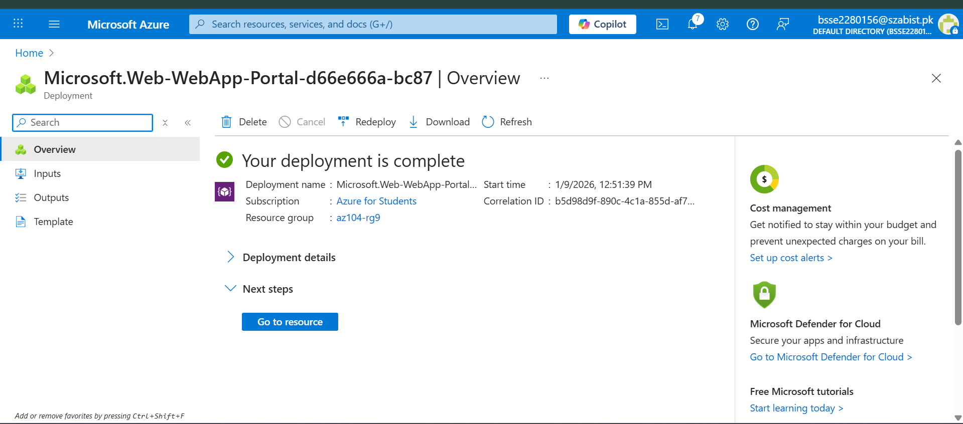

Deployment Succeeded

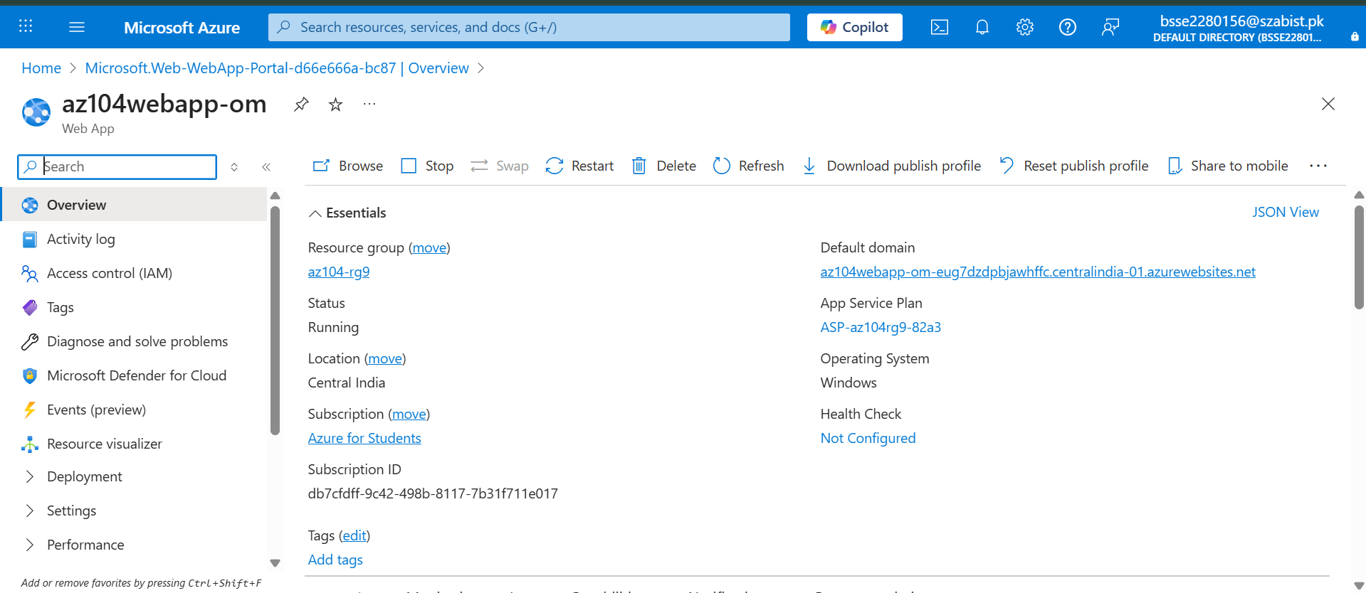

Web App Successfully Running in Azure
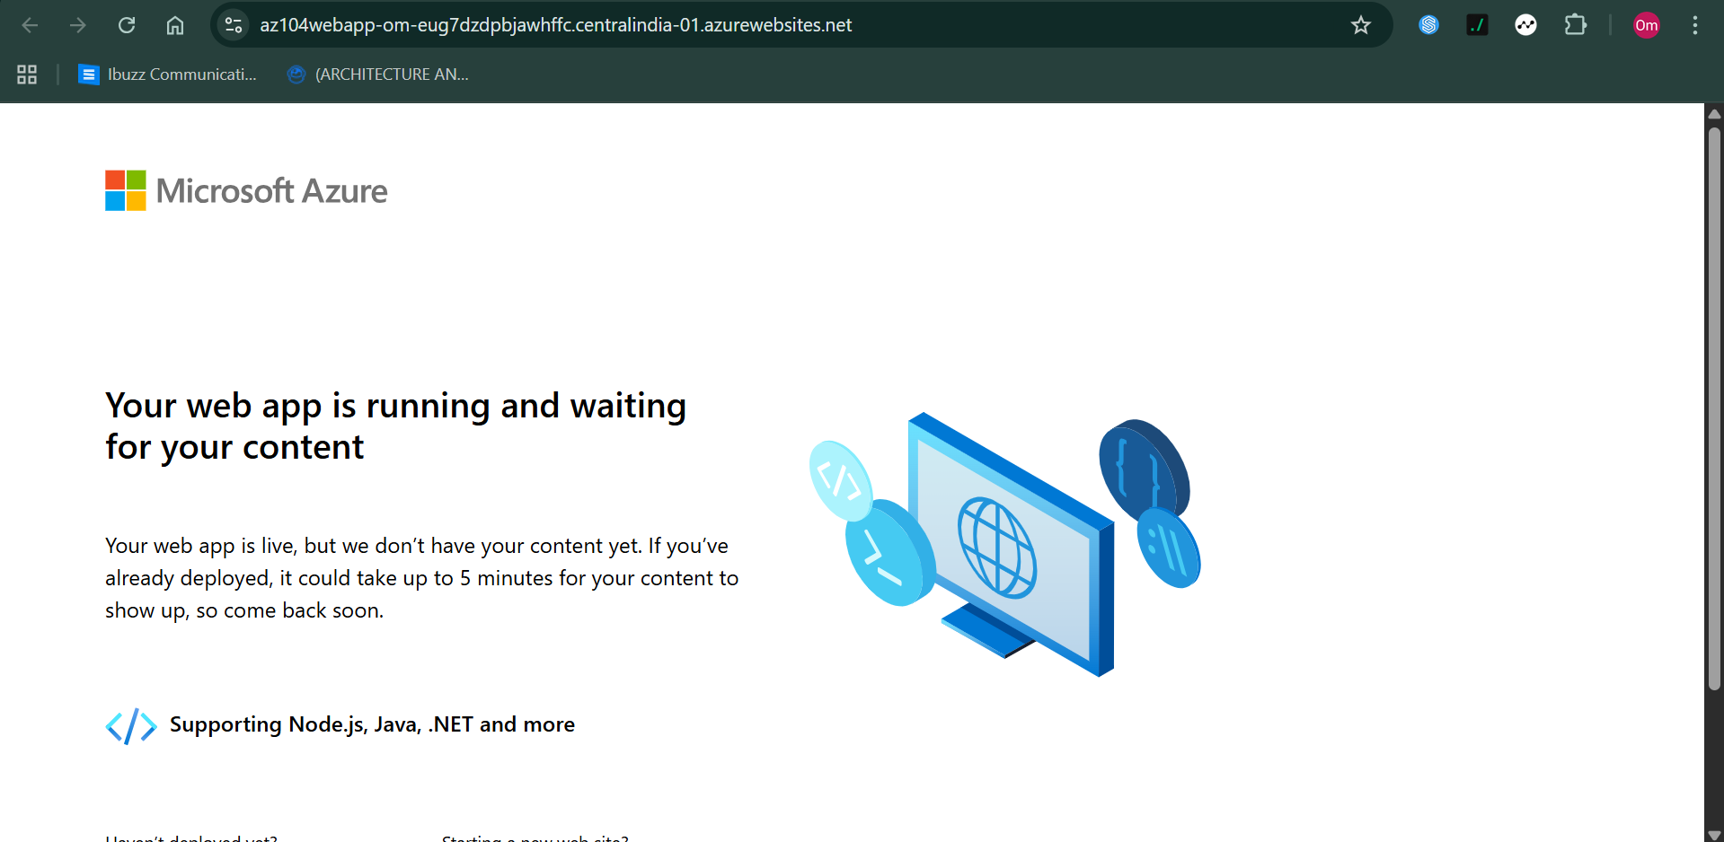

Azure App Service Overview
